Model (Convolutional Neural Network):

1. Build the model

Convolutional Neural Network(CNN) technology is a major advance in image recognition technology. CNN made amazing progress in the ImageNet competition in 2012, increasing accuracy by 10%, this makes CNN technology pay more attention to it and has been applied in many fields. Meanwhile, CNN technology is appropriate for handling our current road sign recognition project, so we decided to use CNN to train our model. By reviewing the data, we found that CNN's main advantages are: Compared to traditional machine learning methods (svm, knn), CNN automatically extracts image features through convolution and pooling, and reduces the dimensions of training data, which is dealing with a large number of high latitudes. Data has a decisive advantage.

1. For the shape of traffic sign

Since our project needs to separately identify the shape and sign of the road sign, we decided to build two convolutional neural networks to classify the shape and sign respectively. First we classify the shape. We reshape the image in the dataset into a 24*24 format, and then one hot encoding the label in the dataset to make it binary, so we complete the preprocessing of the input data. Next is the build model. We choose tensorflow as our development environment to customize our neural network. Through debugging, our model has two layers of convolution and pooling layers and one fully connected layer structure, with the maximum pooling and gradient down optimization, the learning rate is 10^4, and the training is performed step by step. After 2500 steps, the accuracy of the training set reaches 96%. The test set accuracy reached 92.3%. We randomly selected 20 images from the actual measurement to test and get the following results:

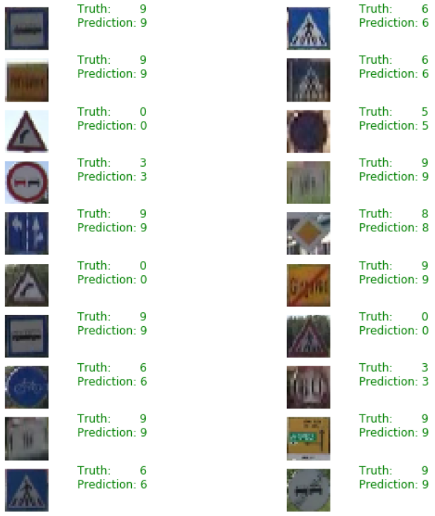

Fig.(shape)result

It can be seen that the model pair is exactly the correct prediction of the image. This is a good result. It can be seen that our model performs very well when identifying the shape of the road sign.

1. For the sign of traffic sign

Next we try to classify the sign. There are a total of 70 categories of symbols in the dataset, and some categories in the test set do not exist in the training set, which has some impact on the accuracy of our classification. We tried to train the sign with the model of the training shape, but the final accuracy was not Satisfactory, only 35%. Therefore, we have to optimize the original model. We tried to increase the number of convolutional layers and tested them in batches with 4 convolutional layers. It was found that over-fitting occurred when the training batch was increased. So we finally set 3 convolution layers, 3 pooling layers and one fully connected layer. After determining the structure of the model, we began to optimize the model.

1. Optimization
2. Batch_size

In the initial training, I chose batch_size = 16 for training. When I found that 100 training steps, the loss of the training set has dropped to nearly 0, and the accuracy is only about 65%. So I decided to increase the batch_size and tested it at batch_size = 64,128,256. The test results are as follows:

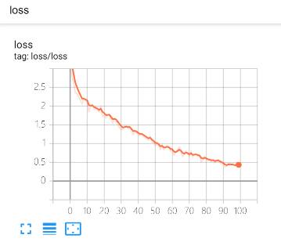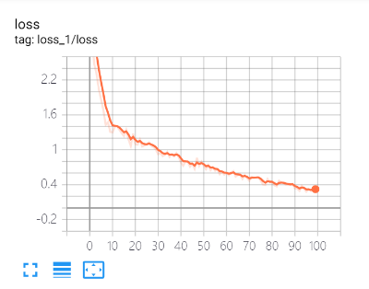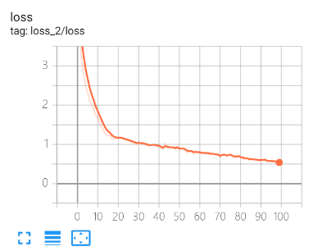

Fig. batch_size=64 Fig. batch_size=128 Fig. batch_size = 256

I found that the larger the batch_size, the faster the loss value drops, and the more severe the overfitting, so we adjusted the overfitting in next steps. And after processing, make a final selection of batch_size.

1. Model

We selected 700 images from the test data as the validation set, and tested the performance of the neural network in the validation dataset during the training process. We found that after training for a period of time, the accuracy of the training set continued to rise, while the accuracy of the validation data set has been around 50%, so we suspect that the neural network has been over-fitting, then the neural network has been adjusted accordingly for the phenomenon of overfitting.

* Dropout：I made a 50% dropout after each pooling layer, and 80% of the dropout before the activation function “softmax” which was passed through the fully connected layer. The overfitting situation was alleviated. It was shown below：

Training set loss map when running 50 epochs：

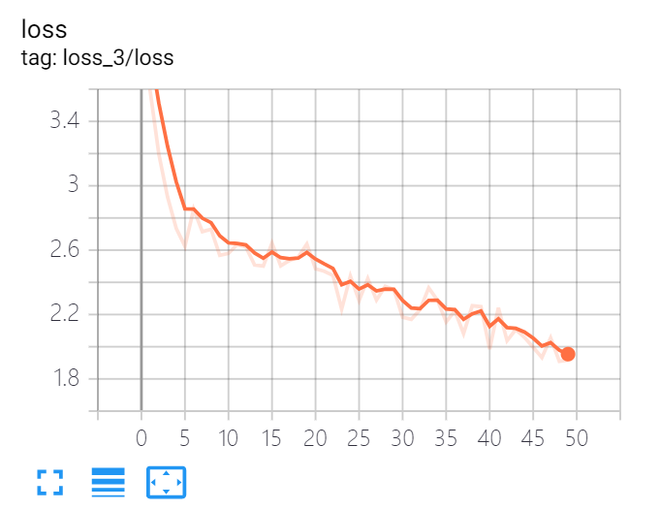

Fig. 50 epochs training loss

We can see that the loss dropping is not as fast as before, indicating that there is still a lot of room for improvement in the subsequent training process, and when running 50 epochs, the accuracy of the training set and the validation set before and after the dropout is compared below: (Although the convergence speed is fast before dropout, the over-fitting phenomenon is also very serious.)

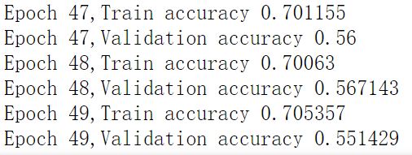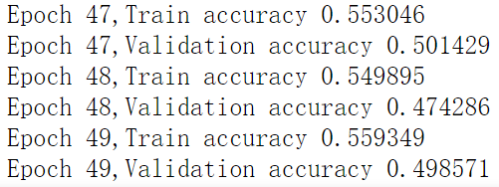

Fig. acc before dropout Fig. acc after dropout

We can find that the over-fitting phenomenon has been solved to some extent.

* Batch Normalization(BN): Firstly, Find the mean of each training batch data, and then find the variance, scale transformation and offset of each training batch data. For most activation functions, the gradient in this region is either the largest or gradient (such as the ReLU we are using), so BN can be seen as an effective means of combating gradient disappearance. In addition, BN is an effective way to avoid over-fitting of models and ensure generalization ability through explicit control model complexity in machine learning. Codes related to BN are shown below: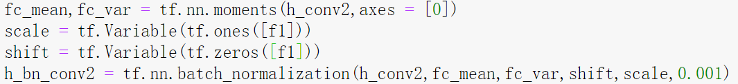

Fig. codes for BN

Similarly, the overfitting phenomenon is alleviated.

1. Learning rate: In the initial training, we chose 1e-3 as the initial learning rate. As the training progresses, the training set loss drops directly to 0. We infer that there is a gradient explosion, so we adjusted the learning rate for the epoch that started the gradient explosion. I made adjustments to the learning rate after 200 epochs. The adjustment is as follows: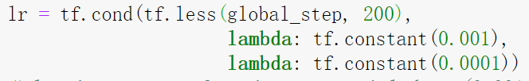

Fig. change learning rate

The situation of the gradient explosion has been solved to some extent.。

1. Deepen the network layer

We hope to increase the accuracy of the training set by increasing the number of neural network layers. As the number of layers of the neural network increases, the accuracy of training continues to rise. However, due to the limitations of the training data, the accuracy of the validation set does not rise. Even in the case of a decline, there is a phenomenon of overfitting. Therefore, after several tests, we selected a three-layer convolutional layer, a three-layer pooling layer, and a two-layer fully connected layer neural network. The network structure we finally use is shown below: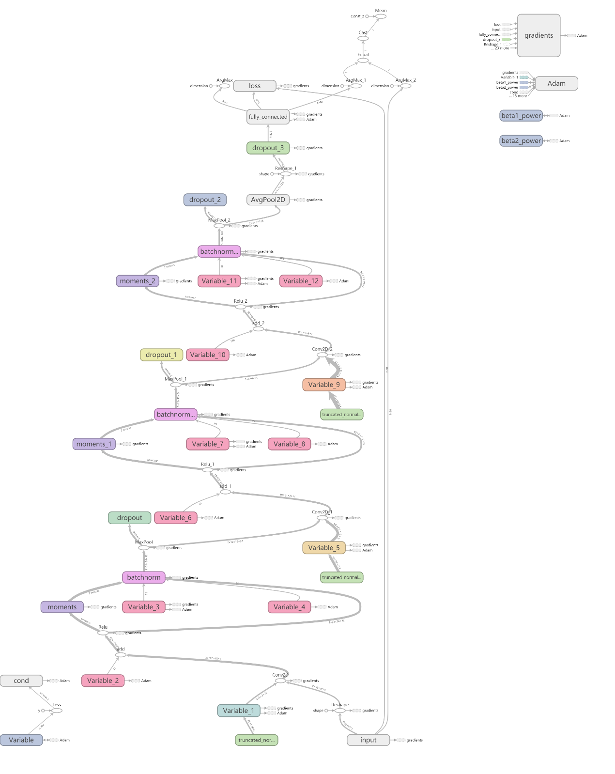

Fig. structure of CNN

1. Results：

The training loss after running 1600 epochs.

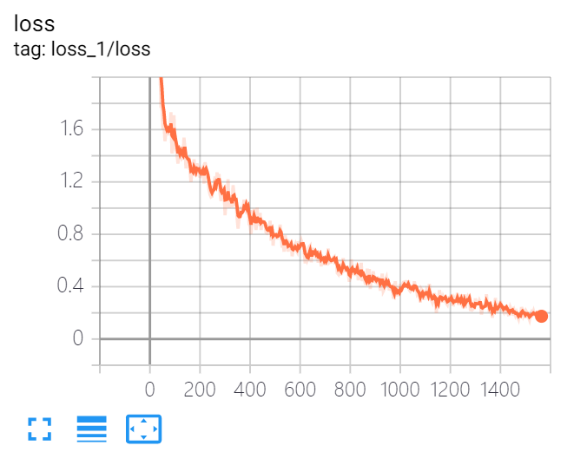

Fig. 1600 steps training loss

The accuracy of the training set and verification set is shown in the following figure:

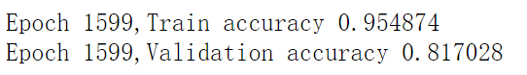

Fig. last epoch training and validation accuracy

The test set accuracy rate is shown in the following figure:



Fig. Train accuracy

We randomly selected 20 images from the test set to match, and the results are shown below:（Green is correct, red is wrong）

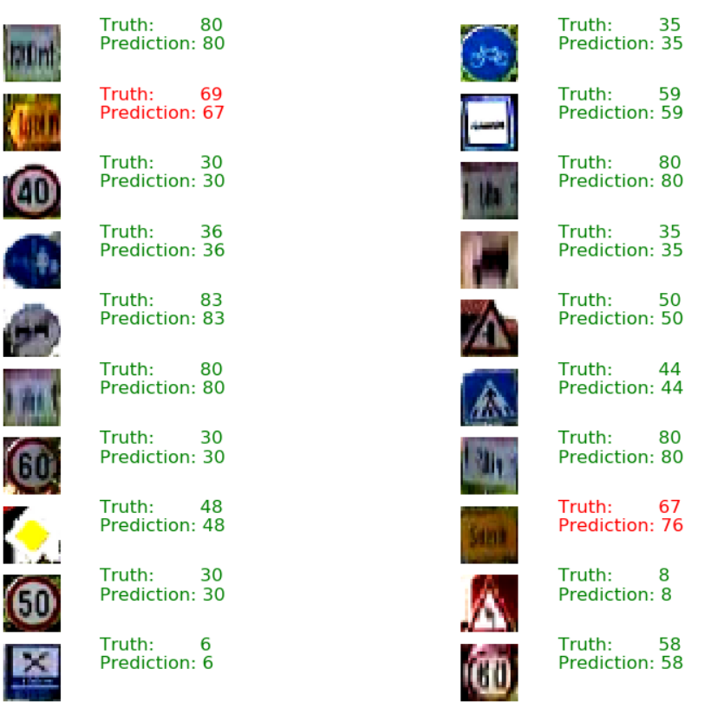

Fig. random test

In summary,

The neural network we built can detect 95% of the shape of the traffic sign and 83% of the meaning of the traffic sign.